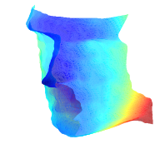
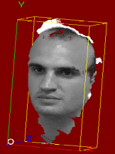

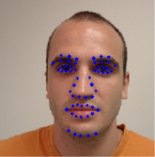
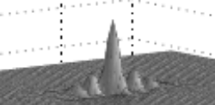

Database
3-D ARG Models
-120
-100
-80
-60
-40
-20
0
20
-80
-60
-40
-20
0
20
40
60
500
550
3D Image
Shape
Texture
AR Graph Modeling
(Shape and Texture)
Log-Gabor Filters
Graph Matching
(Multi-modal)

2-D Attributes
+
3-D Attributes
+
Mutual Relation

Modeling Stage
Recognition Stage

